The Journey of the Mouse Data

* I started with quantile normalized phenotype, gamma=1, and setting the overall threshold for the GEMMA by randomly generating the trait and seeing what the empirical threshold value is (overall threshold value). It came to 5.45 and it gave the following results

Algester-dp:Users:geo047:Desktop:mouseresultsNEW.eps

* I then adjusted the gamma to be based on the formula but not completely happy with this because there is this cutoff of 700 where the gamma value reverts to 1 (this is adhoc). I want to leave it set at 1 father. It does give the following results

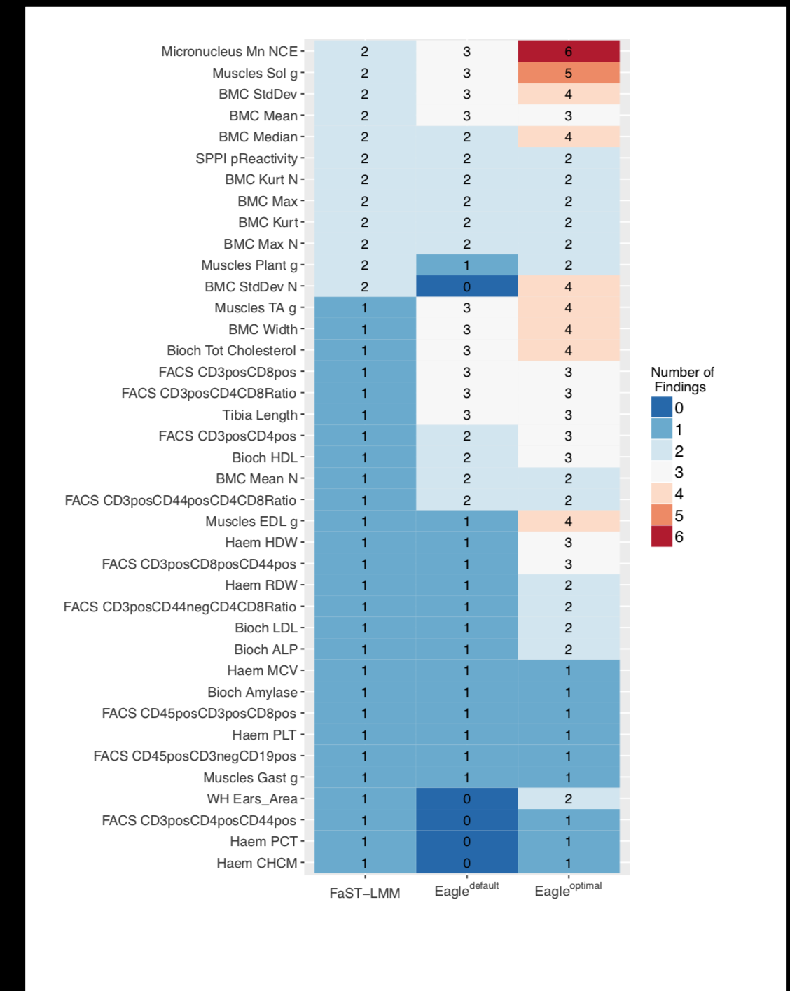

* I then decided to se the threshold more like in the paper where each trait is permuted and the FDR calculated empirically. I found I was now getting much lower thresholds and more results being accepted (even some false positive ones). I tried experiementing with –notsnp option in GEMMA but this doesn’t seem to make much difference to the results. The thresholds were sitill around the 3.5ish mark. I didn’t generate the plot as above but a cursory inspection of the results revealed that GEMMA now found more results. So much so, now there is little difference between GEMMA and the above results for the default value of Eagle. This is contrary to what we were seeing in the simulation study where Eagle was far better, even with a gamma=1.
* I went back to generating a threshold by randomly generating a trait. I confirmed that the significance threshold is 5.45. I then generated a trait, randomly, once, and then permuted it 250 times to look at the threshold. The significance threshold is 5.45 as expected.
* I’m regenerating the normalized data but with a different way of normalising. Instead of perfect normalisation, I’m generating data from a rnorm and using this. (Thursday, 22 November 2018).